How to crack pop1 with CusAsm

First download pop1 and TASM package with TD in it.
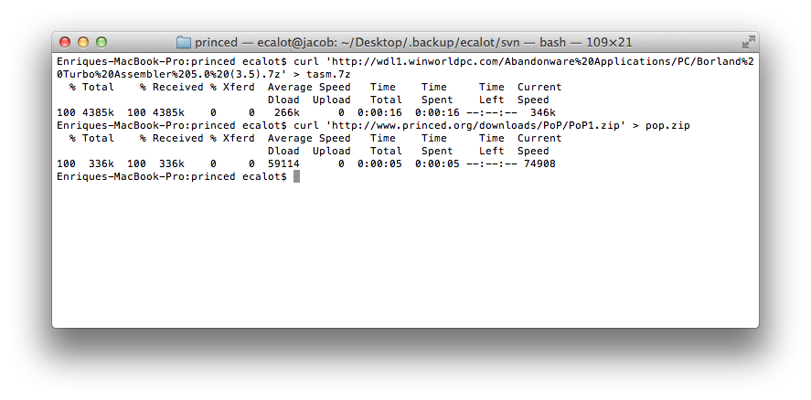

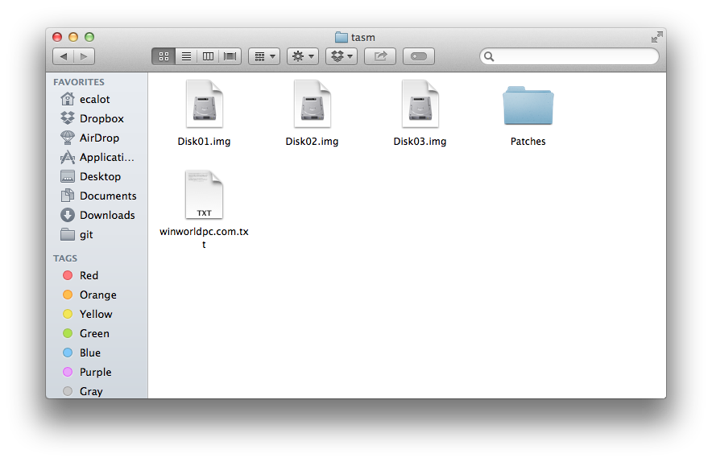
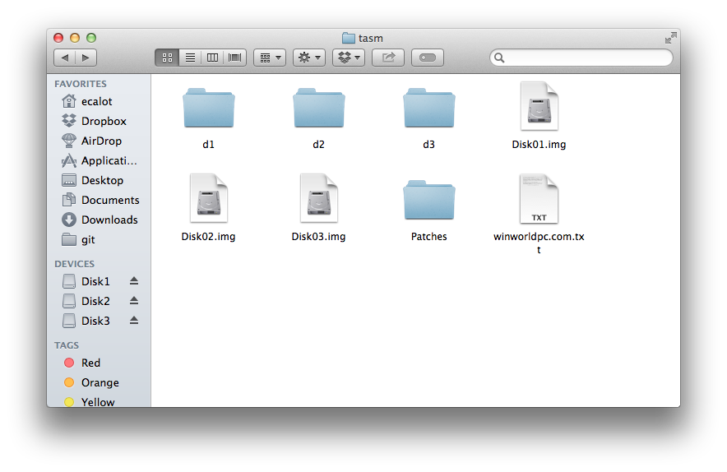

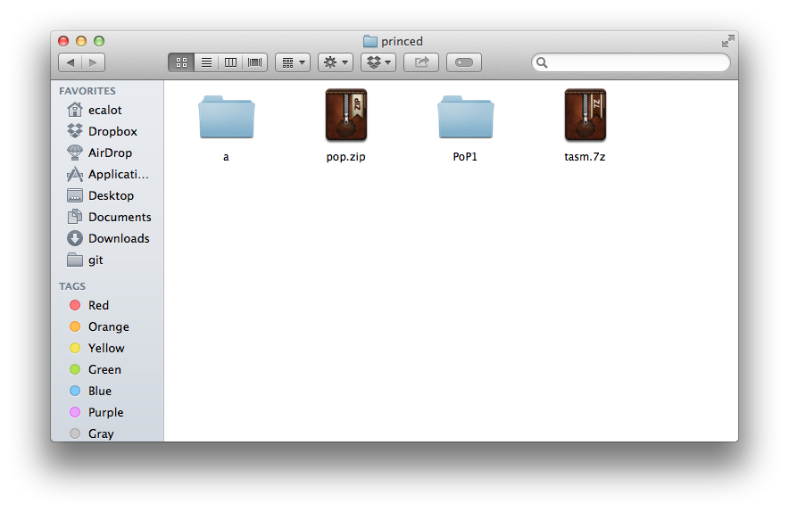

put all disk contents in a directory called “a” so you can mount it as a:

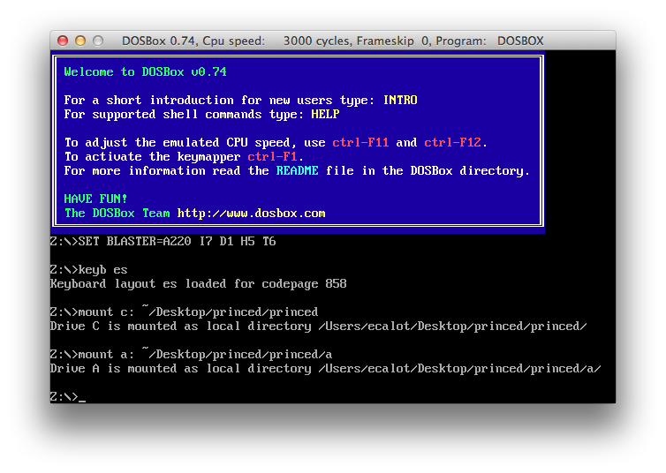
Only 16 bits version of TD is needed
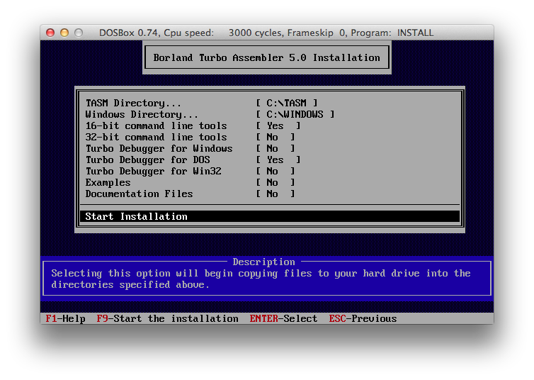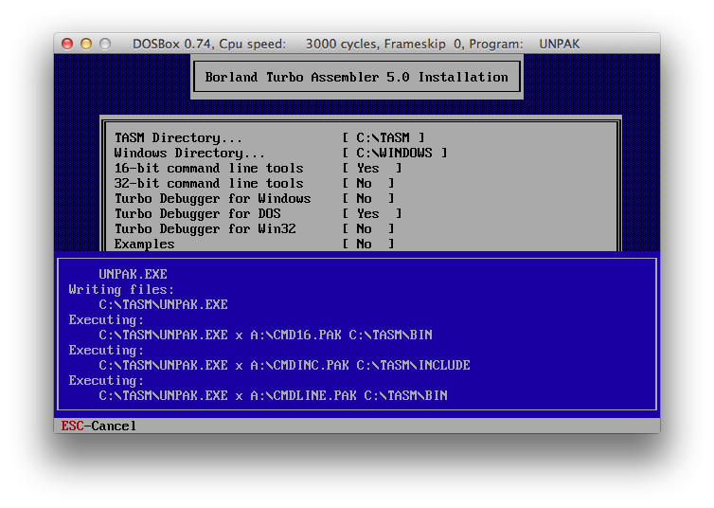

Inside TASM directory run TD in bin.
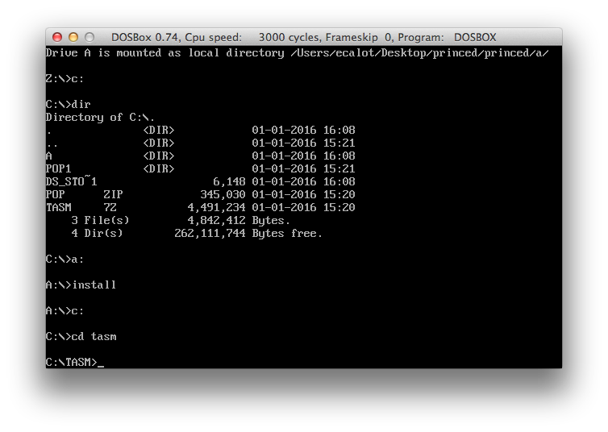

Then first set up the directory to pop1
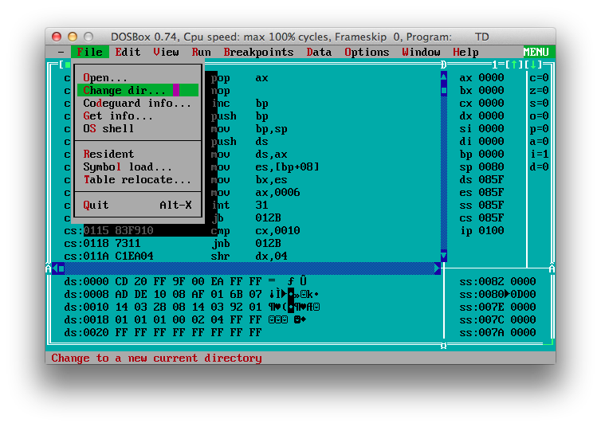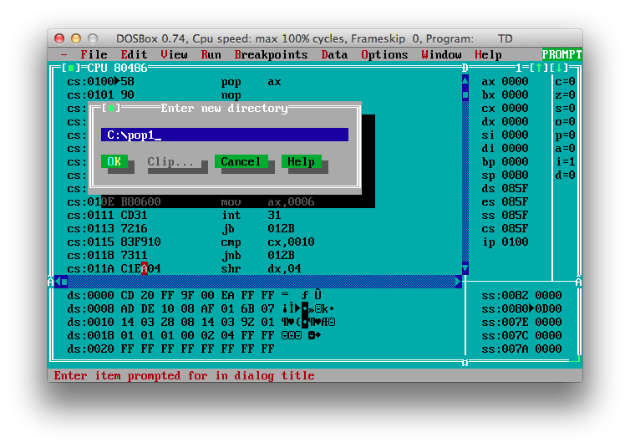
After that open prince.exe
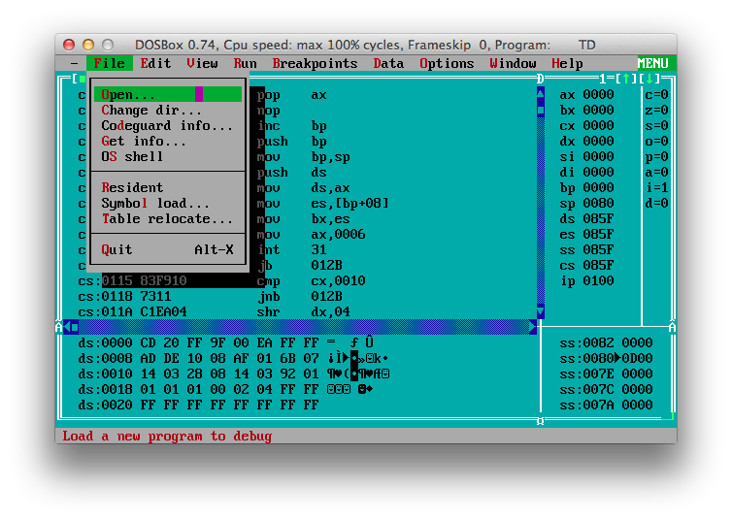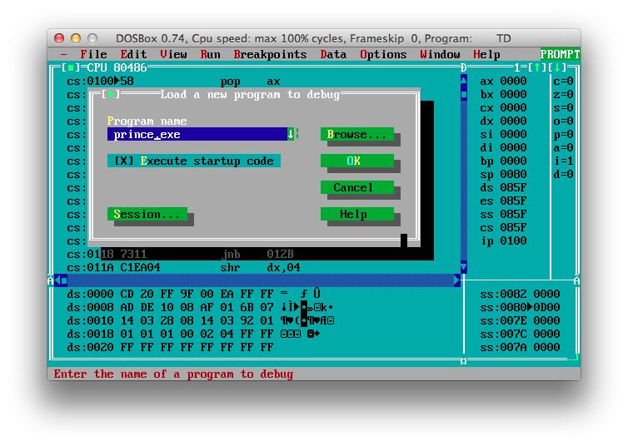
In this tutorial I’m going to move the shadow from level 6 to another screen, so I’ll set up the parameters to “megahit 6” in order to debug faster

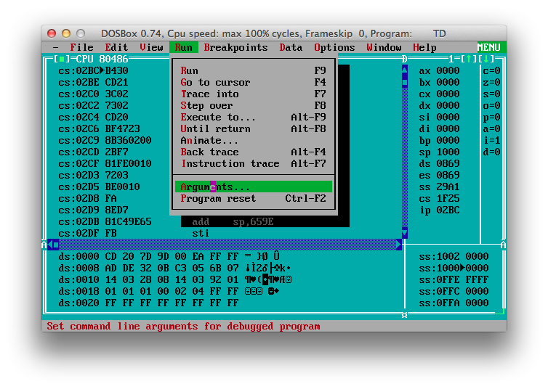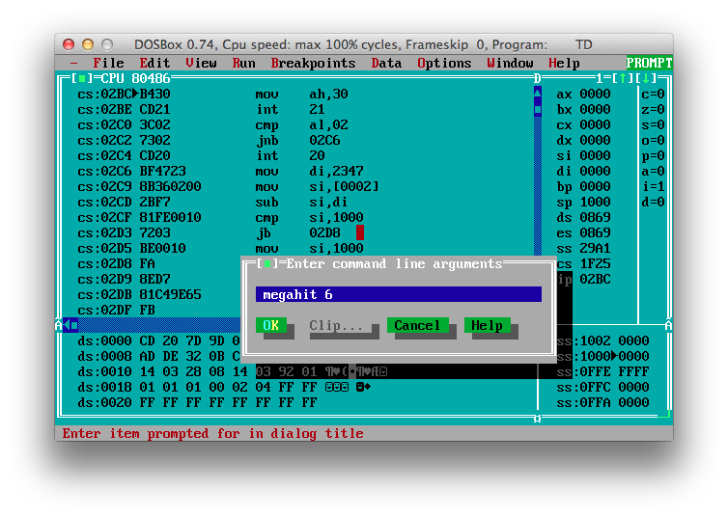
Now, with u,h,j,n it’s possible to navigate the screens inside the game, with c the screen number is shown.

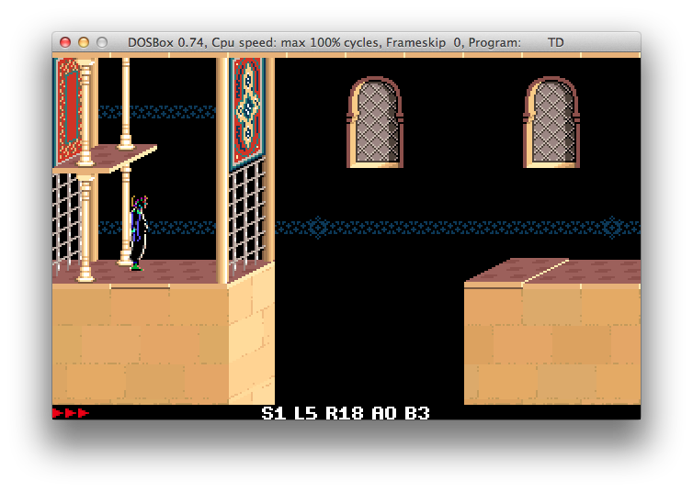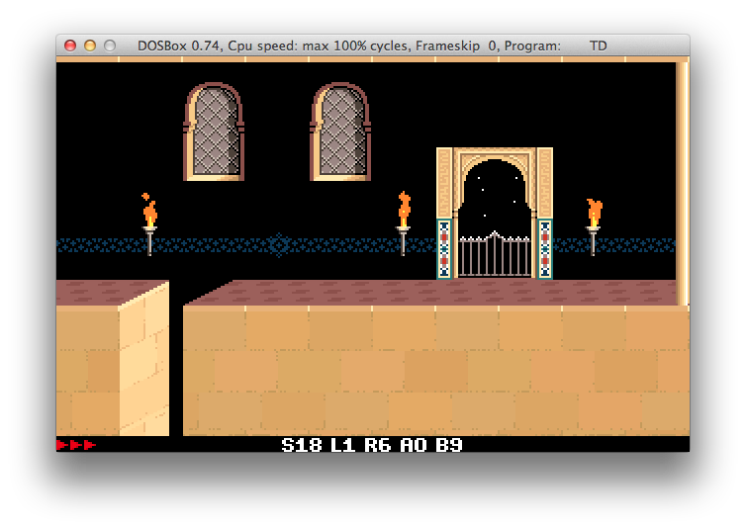
So we are moving the shadow from screen S1 (0x01) to S18 (0x12).

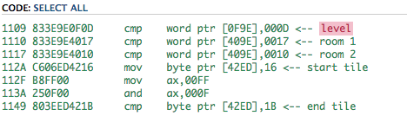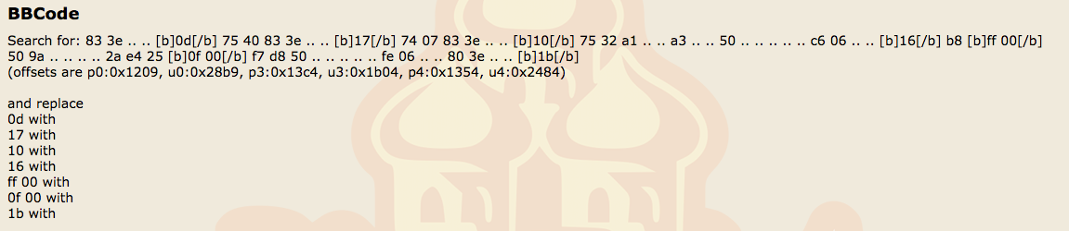

We know that in pop1.0 [0F9E] is the level and [409E] the current room. Other versions have other offsets but it is possible to find the corresponding offset of the version searching for the common code using the right wildcards.

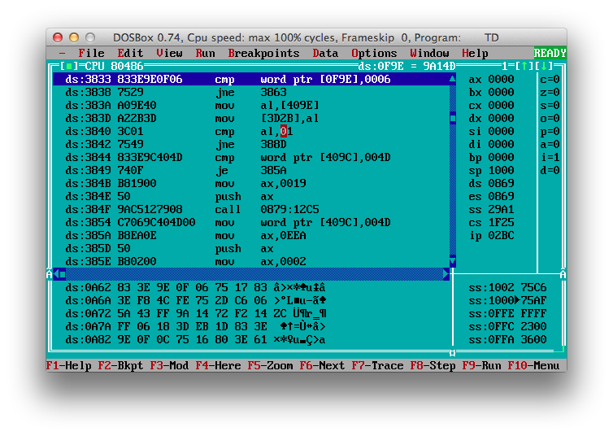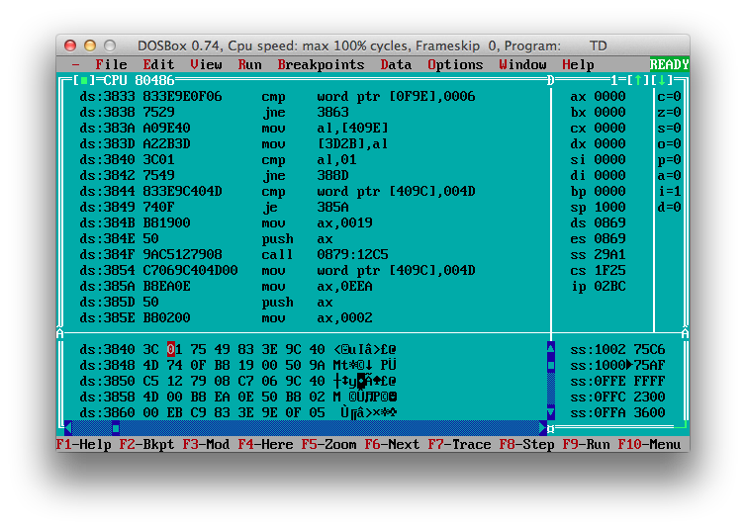
After finding a code where level 6 is compared and screen 1, I’m changing the byte 01 for 12 to test if this is the right place to edit the shadow guy position.
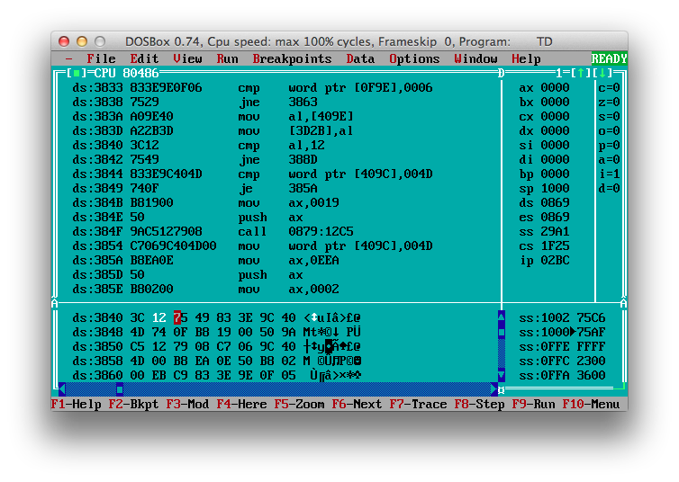

And finally on the first try, the shadow guy has been moved
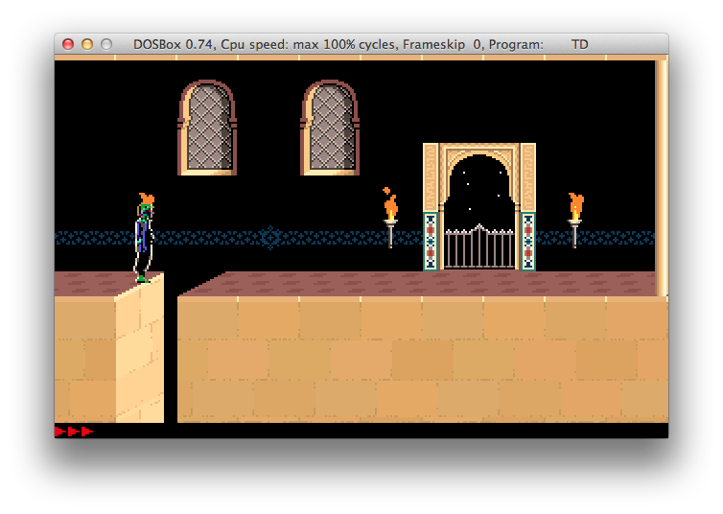

To copy the code, if you are in windows using cmd just copy the rectangle, if not, set up a log file
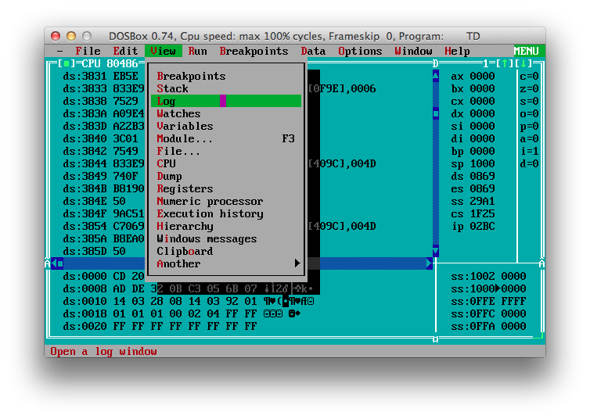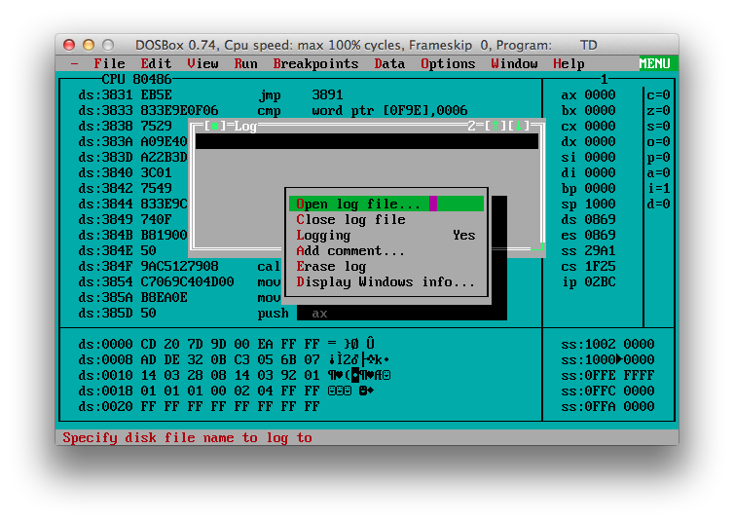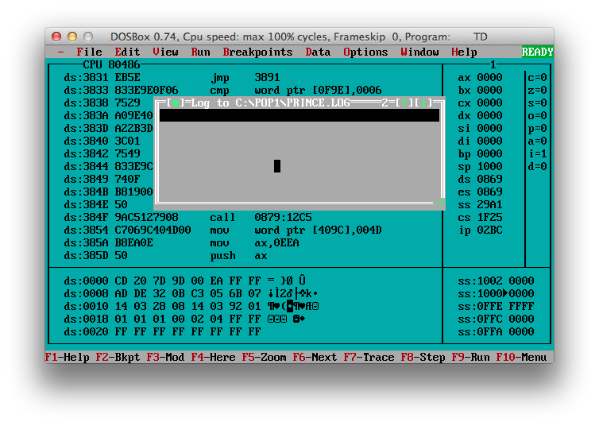
Then click on “dump pane to log”

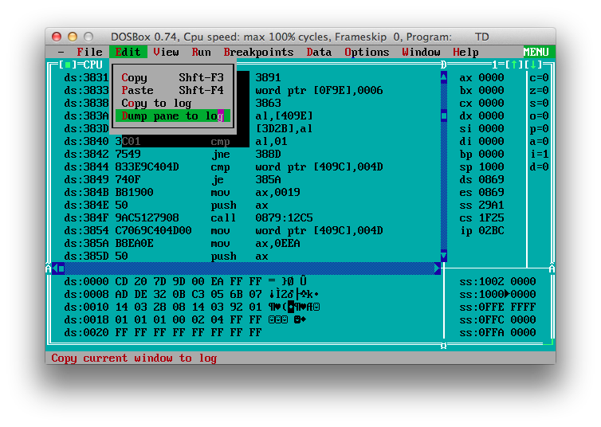

Copy the right lines from the file to cusasm
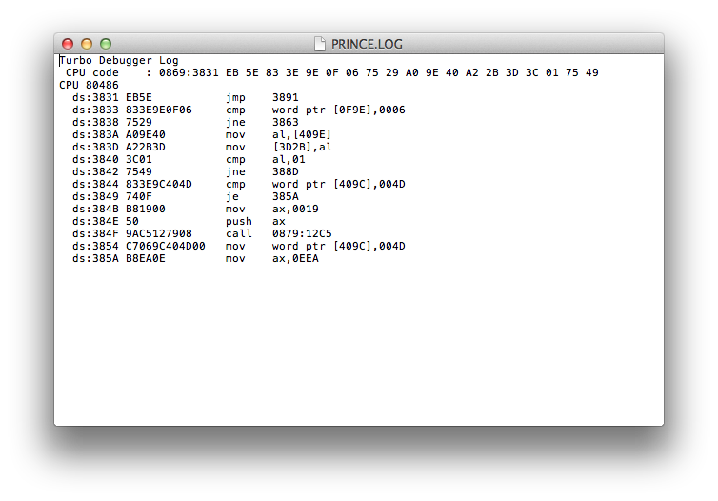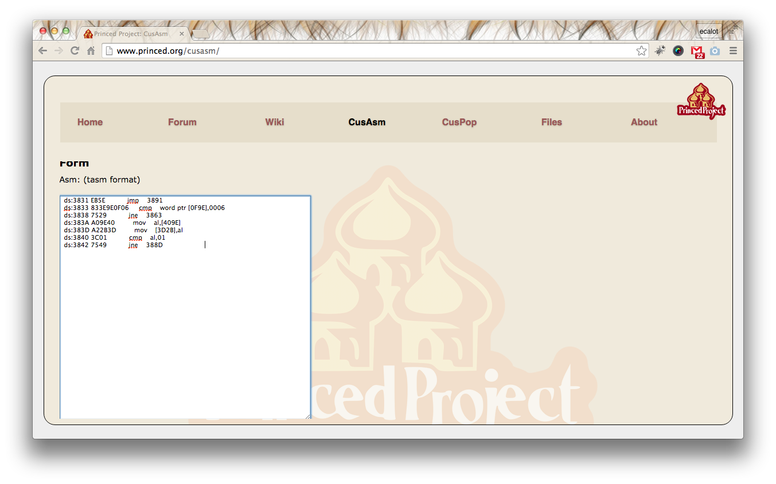

Finally, as CusAsm requires the first column to be 2 hex bytes (even though it is ignored), trim the beginning

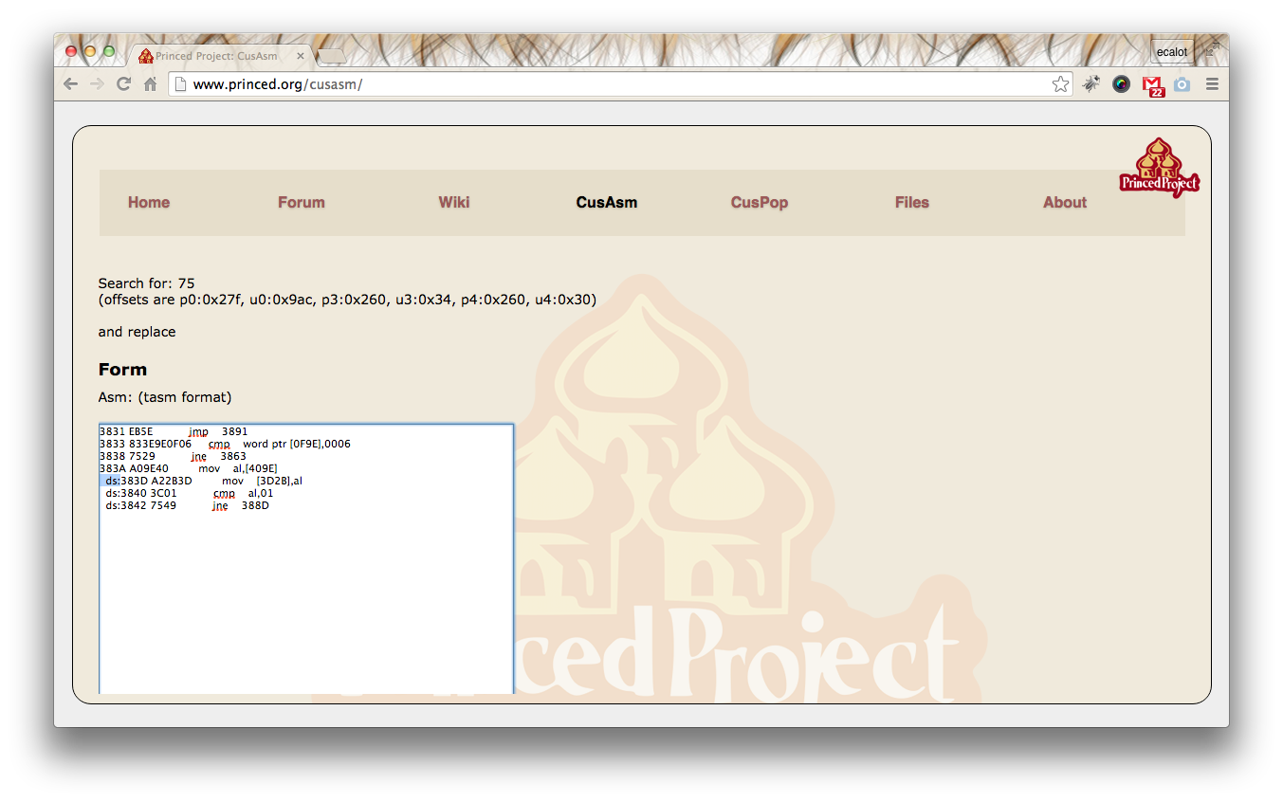

And finally click on “get Code” (twice if possible to generate the mask and then the output).



